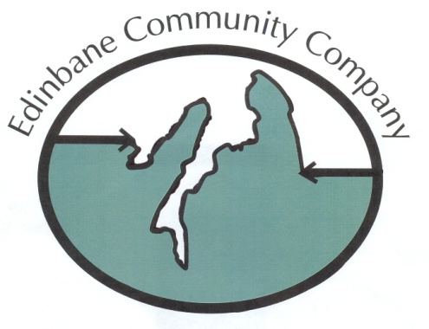
EDINBANE COMMUNITY COMPANY GRANT APPLICATION FORM
(For projects over £ 1,000)

1) PROJECT TITLE.

Name of organisation or individual applicant:
Contact for Correspondence:
Name:
Address:
Tel No:
Email:

In 3 – 4 sentences summarise the main aims and activities of the project. You can attach more information if you wish to the application. Please also state how you will
know whether or not you have achieved your desired outcome.

2) WHAT WILL THE MONEY BE USED FOR?

In 3 – 4 sentences give details of the project, where and when it will take place and
explain how it complies with funding criteria outlined in terms & conditions and the Objects of ECC.

3) FUNDING DETAILS:

Total Project Costs

(Attach a detailed breakdown + evidence of costings – quotes etc)) £

How much are you requesting from the Community Benefit Fund? £

How much will your project contribute? £

Guidance on the percentage of project costs that the fund will support is shown in the
guidance notes.

If you have managed to obtain matching funds, or are applying for matching funds
please list the funds and the amount below:

Organisation(s) applied to: Amount applied for: Confirmed YES / NO

(If yes please give date of award, if no give date when decision of award is expected)

In the event of a successful outcome payments will be made directly into a nominated
bank account. Please provide details of your nominated bank account.
Bank or Building Society Name:
Sort code:
Account name:
Account number:

Please note depending on the amount of an award payments may be made in instalments, on submission of invoices and receipts. This will be detailed in the “offer” letter.

REFEREES:

The Directors may request references in support of any application, it is recommended
that applicants provide testimonies for key project applicants and attach them to this
application.

ADDITIONAL DOCUMENTATION:

If you are a constituted organisation please provide:
a) A copy of the constitution
b) A copy of the most recent annual accounts
c) A list of membership of the current management committee.

STATEMENT:

To the best of my knowledge the information on this form gives a true an accurate
account of this organisation’s work and needs. I confirm that I am authorised to
complete this application and have read and agree to the terms and conditions:
1. The Edinbane Community Co. must be acknowledged as a supporter of
the project in any public announcements
2. The Edinbane Community Co reserves the right to publicise this
assistance and include it in a public record of grants
3. The Edinbane Community Co. Will require to see copies of all invoices
paid and receipts etc in respect of this project.
4. The decision of the Directors of the Edinbane Community Co is final,
once a decision is made the Board will not enter into any further correspondence or discussion on the decision.

Signed: Authorised Signatory / Director 1

Authorised Signatory / Director 2
Date:

Please return completed application form to the Secretary
Stuart Whatley, ECC Secretary, Edinbane Pottery, Edinbane, Isle of Skye IV51 9PW details on directors page

TERMS & CONDITIONS + GUIDANCE FOR APPLICANTS

Principles of the Fund:
The fund can be used for projects defined under the “Objects” of the Company’s
Articles and Memorandum of Association which includes initiatives:

1.To manage community land and associated assets for the benefit of the Community and the public in general as an important part of the protection and sustainable development of Scotland’s natural environment, where ‘sustainable development’ means development which meets the needs of the present without compromising the ability of future generations to meet their own needs.

2.To promote the benefit of the inhabitants of the Community, without distinction on grounds of race, gender, political, religious, or other opinions, by associating with the local statutory authorities, voluntary organisations and inhabitants in a common effort to advance education. Further to provide direct financial support to any inhabitant or inhabitants of the Community (i) entering into tertiary education and /or (ii) for small community development type projects.

3.To provide, or assist in providing, facilities for recreation and other leisure time occupation for the benefit of the inhabitants of the Community, following principles of sustainable development and in the interests of social welfare so that conditions of life may be improved.

4.To advance the education of the Community about its environment, culture and/or history.

IT IS SUGGESTED THAT IF YOU ARE UNCLEAR AS TO WHETHER YOUR PROJECT FITS WITH THE “OBJECTS” OF THE COMPANY THAT YOU DISCUSS THE APPLICATION WITH A DIRECTOR BEFORE MAKING A SUBMISSION
(For a list of directors please see website – http://www.edinbanecommunitycompany.org/ )

The Company is prepared to consider 100% funding in exceptional circumstances for
applications but in general applicants are expected to raise some monies from some
other sources. This is to enable the Company to maximise the benefit of the funds that it has at its disposal.

IT IS SUGGESTED THAT YOU DISCUSS FUNDING APPLICATIONS WITH A DIRECTOR BEFORE MAKING A SUBMISSION.

There is a separate list of Directors on the website.

The fund may not be used for the following:
For the promotion of any specific political or religious purpose.
2) To replace funding for projects already funded through the public sector
IF IN ANY DOUBT DISCUSS THIS ISSUE WITH A DIRECTOR
3) To oppose, obstruct or object to the development, construction or operation of
the Wind Farm or any other wind farm.
4) For projects or activities that are contrary to the interests of the Windfarm.

HOW YOUR APPLICATION WILL BE ASSESSED

Your application will be assessed by a full quorum of Directors of the Edinbane Community Co
at a Company Business meeting that will take place on a quarterly basis. Funding may be
awarded in full, or in part depending on the availability of funding and the positive stated
outcomes that the funding will achieve. Applicants will be required to sign a grant acceptance
form prior to the release of the funding.

STIPULATIONS:

Successful applicants will be required to sign the Grant Acceptance Form prior to the
award of a grant (Page 8)

This acceptance carries the following stipulations:

- Monitoring will take place between six and nine months after the award was made. At this time, you will be requested to attend a meeting with Directors of the Edinbane Community Co. An itemised breakdown of actual expenditure against budget in relation to this award must be submitted before this meeting.
Copies of relevant invoices and receipts must also accompany this.

- A report of progress and accomplishments must also be submitted at this time.

- Organisations are expected to co-operate in the production of reports as requested. The Co.
reserves the right to have access to the Staff, Management Committee, committee papers and other records of the organisation receiving the grant.

- Acknowledgement of the financial support from the Edinbane Community Co. should be given in all publications relating to that of which it was financially assisted.

- Any portion of the grant, which is not used as specified in the application form, shall be
returned to Company unless prior written consent is given for it to be used otherwise.

- In the event that the project is unable to achieve its objectives the Company shall recover any remaining funding. Where the purchase of equipment is involved, the applicant organisation must agree with the Company how this equipment will be disposed of.

- Where the delivery of a project is delayed the Directors of the Community Co. must be advised and an explanation provided.
FOR EDINBANE COMMUNITY CO. USE ONLY

CONFIRMATION OF GRANT

Constitution enclosed?

Annual Accounts enclosed?

List of Committee members enclosed?

Decision:

PRIVACY STATEMENT

Please tick the box below giving us permission to use the information you have supplied for the following purposes:
- To store it securely for membership purposes
- To communicate with you as an ECC member
- To send you general information about ECC or communications that we feel may be of interest to you
- Financial awards where appropriate
□ I consent to my data being used for membership purposes as detailed above.

Please be advised that you can request for your data not to be used for any of these purposes at any time by contacting the ECC at eccgdprenqs@gmail.com .

Please be assured that your data will not be used for marketing purposes or passed on to third parties.

You may, at any time, request a copy of your data from the address below.

Communications with you

I consent to the ECC contacting me for the above purposes by:

□ Post □ Email □ Phone Please tick all those that apply

The full Policy is displayed on the ECC website http://www.edinbanecommunitycompany.org and if you require your own copy please contact the ECC at eccgdprenqs@gmail.com .

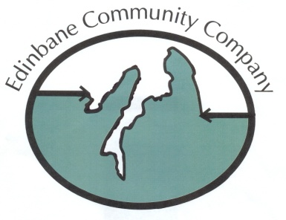

ECC GRANT ACCEPTANCE FORM

The (Name of Organisation) ………………………………………………………………….
agree to the conditions stated in your application and that the grant will be used exclusively for the purposes outlined in the application form and subsequent grant offer letter.

I..…………………………………. accept the grant on behalf of
……………………………………………………………………… (Name of Organisation)
I……………………………………decline the grant on behalf of
…………………………………………..…………………………. (Name of Organisation) as the grant is no longer required / funding has been secured via another source.

Signature: Date:
Designation:
Details of recipient:
Name of organisation:
Title of project:
Contact name:
Address:

THIS FORM MUST BE COMPLETED AND RETURNED WITHIN 14 DAYS OF THE DATE OF THE AWARD LETTER.

Please return the form to the Secretary:
Stuart Whatley (Secretary Treasurer)
Edinbane Pottery, Edinbane, Isle of Skye IV51 9PW 01470 582 234

